**Earth Day 2023, SUNY Empire State University**

**Bios and Photos for Presenters**

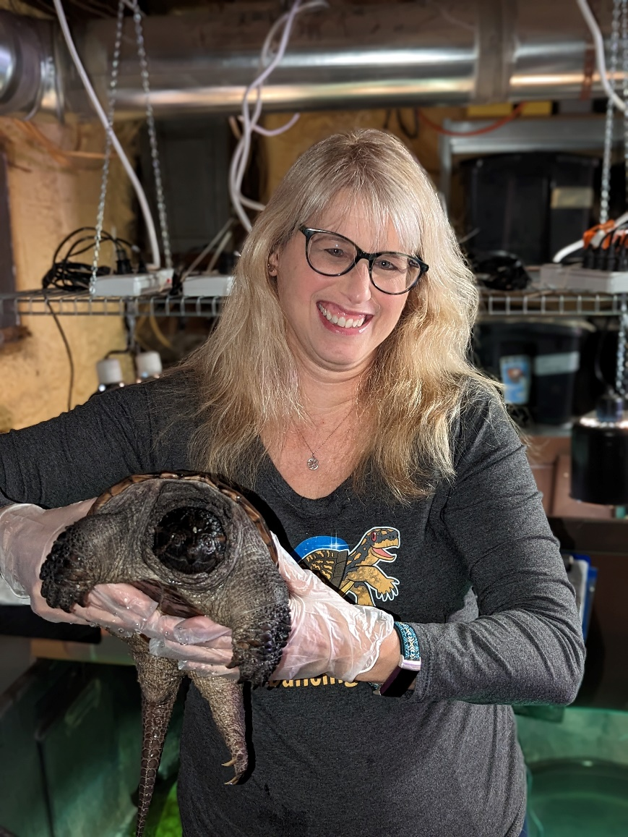

Debbie Philp is a licensed wildlife rehabilitator and is currently the president of North Country Wild Care, an organization of wildlife rehabbers and other volunteers who help each other help injured and orphaned wild animals from the Albany area into the Adirondacks. Part of their nonprofit's mission is to help us all learn about wildlife and what we can do to help wildlife thrive alongside us.

Learn more about North Country Wild Care: [North Country Wild Care – Emergency Hotline: (518) 964-6740](https://northcountrywildcare.org/)

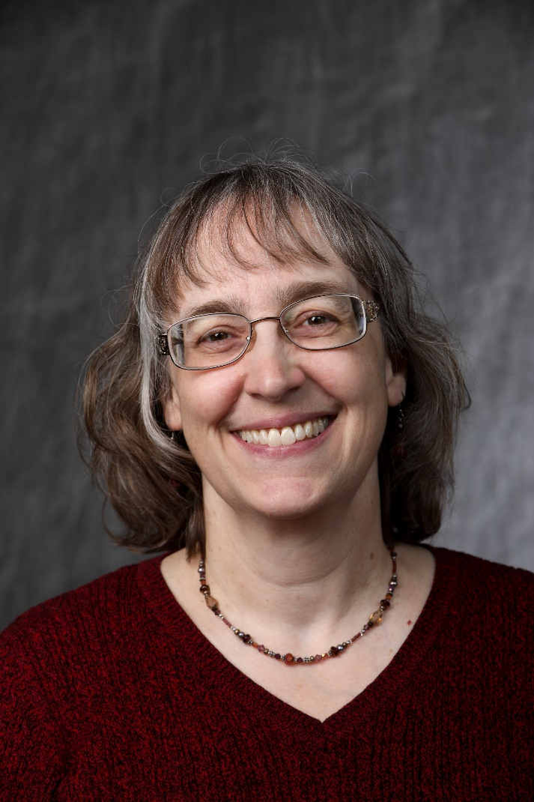

Mindy Boenning is a garden enthusiast and has been learning about gardens, and the plants and animals in them, for over 30 years. Mindy is also the Army Program Coordinator for SUNY Empire State University, and has worked with military-affiliated students at the Fort Drum Army installation since 2006. Mindy has worked in higher education since 1993 in student services, academic advising, teaching, and administration.